**DAV HZL SR. SEC. SCHOOL, DARIBA**

**TENTATIVE CO-CURRICULAR ACTIVITIES 2024-25**

|  |  |  |
| --- | --- | --- |
| **Date** | **Class** | **Activity (Event)** |
| 06/04/2024 | III TO V | Cinematic Odyssey: Arya Samaj Chronicles |
| VI TO VIII | Narrative Alchemy: Crafting English Tales |
| IX TO XII | Lens Enchantment: Interclass Cinematic Journey |
| 20/04/2024 | III TO V | Soliloquy Symphony: Mastering English Monologues |
| VI TO VIII | Dramatic Flourish: Theatrical Skits in English |
| IX TO XII | Electoral Insights: Interclass PowerPoint Showdown |
| 04/05/2024 | III TO V | Artistry Unleashed: Collage Creation Extravaganza |
| VI TO VIII | Sculpting Stories: From Clay to Chronicle |
| IX TO XI | Pixel Perfection: Design Delights with Photoshop |
| 05/07/2024 | III TO VIII | Green Horizon: Plantation Expedition |
| 06/07/2024 | III TO V | Calligraphy |
| VI TO X | Echoes of Ecology: English Environmental Orations |
| 11/07/2024 | III TO XII | Leadership Unveiled: Investiture Spectacular |
| 20/07/2024 | III TO V | Lexical Showdown: Spellbinding Spell Bee |
| VI TO VII | Verbal Voyage: Vocabulary Ventures |
| IX TO XI | Enlightening Discourse: TED Talk Showdown |
| 03/08/2024 | III TO V | Culinary Chronicles: Fireside Cooking & Artistry |
| VI TO IX | Taste Temptations: Culinary Competition |
| 17/08/2024 | III TO VIII | Cultural Kaleidoscope: Rangoli, Rakhi& Arya Samaj Quizzes |
| 31/08/2024 | III TO V | Social Science Showdown: Quiz Quest |
| VII TO X | Parliamentary Prowess: Youth Debate Showdown |
| 06/09/2024 | III TO V | Hindi Heritage: Crafting Original Stories & Poems |
| VI TO VII | Hindi Heritage: Crafting Original Poems |
| VIII TO X | Declamatory Divinity: Hindi Oratory Odyssey |
| 05/10/2024 | III TO V | Blogosphere Brilliance: Crafting Digital Chronicles |
| VI TO VII | Wall Wonders: Mural Masterpieces |
| VIII | Wonders on earthen plates |
| 19/10/2024 | III TO V | Moral Mosaic: Hindi Skits on Values |
| VI TO IX | Theatrical Tribute: Great Personality Dramatizations |
| 08/11/2024 | III TO V | Melodic Medley: Songster Showdown |
| VI TO IX | Devotional Delights: Bhajan Bliss |
| 23/11/2024` | III TO V | Innovation Illuminated: Inventors' Showcase |
| VI TO VII | Journey of a Dreamer;Biography |
| VIII TO IX Sci. | Scientific Sorcery: Enchanting Science Magic |
| 07/12/2024 | III TO V | Literary Legacy: Bookmark Bonanza |
| VI TO VIII | Informative Imprints: Brochure Brilliance |
| 21/12/2024 | III TO IX | Math Marvels: Exploring Fun & Practical Mathematics |
| 18/01/2025 | III TO VII | Patriotic Penmanship: Slogan Sketching & Doodling |
| 31/01/2025 | III TO V | Resourceful Innovation: Waste Material Wonders & Presentations |

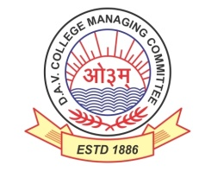

DAV HZL Sr. Sec. School dariba

rajsamand (raj.)

DAV HZL Sr. Sec. School dariba, rajsamand(raj.)

Split-up Syllabus

Class- III

Split-up Syllabus & Activities

for the session

2024-25

Class-III

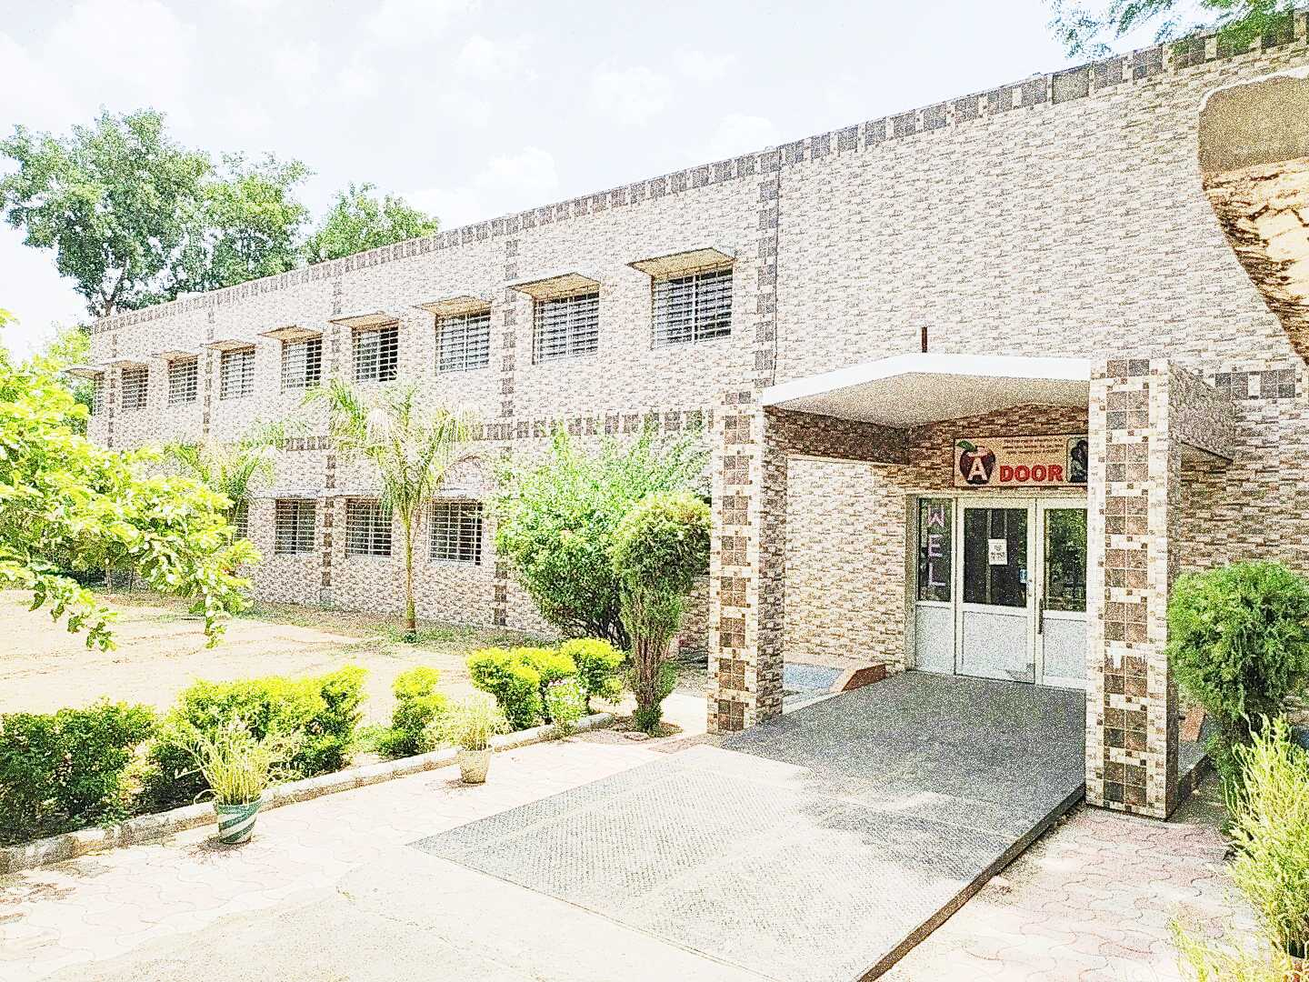

Address : Rajpura-Dariba, Distt. – Rajsamand (Raj.) 313211

Contact : (02952)265130 Email : davhzl_dariba@yahoo.com Website : www.davhzldariba.in

|  |  |  |
| --- | --- | --- |
| **Subject** | **PT- I** | **PT- II** |
| English | Reader book- L-1  Practice book- L-1 | Reader L-2  Practice book-L-2 |
| Hindi | पाठ 2 व 3 भाषा माधुरी, भाषा अभ्यास | पाठ 5 व 6 भाषा माधुरी, भाषा अभ्यास |
| Maths | Ch.-1,2 | Ch.- 3,4 |
| EVS/ Science | Ch.-1 and 2 | Ch.-3 and 4 |
| S.St. | Ch.-1 and 2 | Ch. 3 and 4 |
| Computer Sci. | Ch.- 1 | Ch.-2 |
| Moral Edu. | पाठ - 1 , 2 | पाठ - 3 , 4 |
| G. K. | Unit - 1 | Unit-2 |

|  |  |
| --- | --- |
| **Subject** | **Mid Term** |
| English | Reader –L – 3,4,5,6,7  Practice book- L- 3,4,5 composition, Reading and understanding |
| Hindi | पाठ 1 से 8 भाषा माधुरी, भाषा अभ्यास पठित गदयांश |
| Maths | Ch.- 1 to 6 |
| EVS/ Science | Ch. – 1 ,2,3,4 and 5 |
| S. St. | Ch.- 1 to 7 |
| Computer Sc. | Ch.- 1-4 |
| Moral Edu. | पाठ – 1 to 7 |
| G. K. | Unit- 1 to 3 |
| Drawing | Page no. 2 to 20 |

|  |  |
| --- | --- |
| **Subject** | **PT- III** |
| English | Reader L-8 to 10  Practice L-6 .Preposition |
| Hindi | पाठ 9 व 11 भाषा माधुरी व भाषा अभ्यास |
| Maths | Ch.-7, 8 |
| EVS/ Science | Ch.- 6 and ch- 7 |
| S.St. | Ch.- 8 and 9 |
| Computer Sc. | Ch.-5,6 |
| Moral Edu. | पाठ - 8,9 |
| G. K. | Unit - 4 |

|  |  |
| --- | --- |
| **Subject** | **Final Term** |
| English | Reader- unit 3, unit 4  Practice book L .- 7,8,9,10  Composition Reading for understanding |
| Hindi | पाठ 9 से 16 भाषा माधुरी व भाषा अभ्यास पठित गदयांश |
| Maths | Ch. 4,5,7 to 12 |
| EVS/ Science | Ch.- 6,7 8,9, 10 |
| S. St. | Ch.- 8 to 14 |
| Computer Sc. | Ch.-5,6,7,8 |
| Moral Edu. | पाठ - 8 से 13 , आर्य समाज के नियम 1 व 2 |
| G. K. | Unit - 4 to 6 |
| Drawing | Page no.21 to 40 |

|  |  |
| --- | --- |
| **Exam** | **TENTATIVE DATES OF EXAM** |
| **PT – I** | First Week of May 2024 |
| **PT- II** | First Week of August 2024 |
| **MID – TERM** | Third Week of September 2024 |
| **PT – III** | Last week of November 2024 |
| **FINAL TERM** | Last Week of Feb.2025 |